**Experiment 11: Write a Program to read PH value from various substances like**

**Lime, water and Milk using PH sensor with Arduino Board**

**Date : 16.10.2025**

**Aim:**

To write a program to read PH value from various substances using a PH sensor with Arduino Board.

**Components Required:**

|  |  |  |  |
| --- | --- | --- | --- |
| **S.No** | **Components Name** | **Range/Rating** | **Quantity** |
| 1 | Universal Bread Board |  | 1 |
| 2 | Arduino Uno board |  | 1 |
| 3 | Ph sensor |  | 1 |
| 4 | Potentiometer (to simulate pH sensor output) |  | 1 |
| 5 | LCD Display Board |  | 1 |
| 6 | USB Cable |  | 1 |
| 7 | Jumper Wires |  | required |

**Hardware Setup:**

**Connect LCD Display with Digital Pins**

**Connect PH Senor pin with A0 and other pin with +5vcc and GND**

**Arrange the wires as in the following diagram**

**PH sensor 4502C**

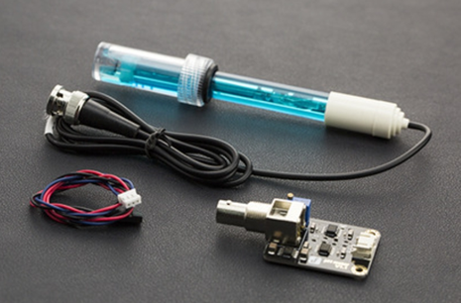

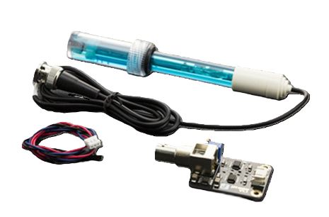

**Connection Diagram: -**

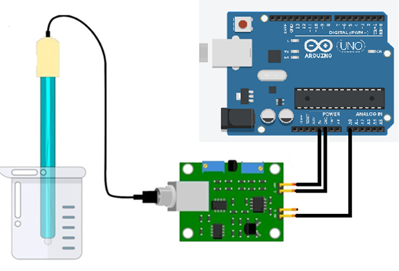

**Program**

const int potPin=A0;

float ph;

float Value=0;

void setup() {

  // put your setup code here, to run once:

  Serial.begin(115200); // or Serial.begin(9600)

  pinMode(potPin,INPUT);

  delay(1000);

}

void loop(){

    Value= analogRead(potPin);

    Serial.print(Value);

    Serial.print(" | ");

    float voltage=Value*(3.3/4095.0);

    ph=(3.3*voltage);

    Serial.println(ph);

    delay(500);

}

**Simulate in Tinkercad**

1. Components Needed:
   * Arduino Uno
   * Potentiometer (to simulate pH sensor output)
   * Wires and Breadboard
2. Setup:
   * Connect the middle pin of the potentiometer to A0 on the Arduino.
   * Connect one side pin of the potentiometer to 5V and the other to GND.
   * Upload the code to the Arduino in Tinkercad.
3. Simulation:
   * Adjust the potentiometer to simulate different pH levels.
   * Open the Serial Monitor to view the analog value, voltage, and simulated pH value.

**OutPut**

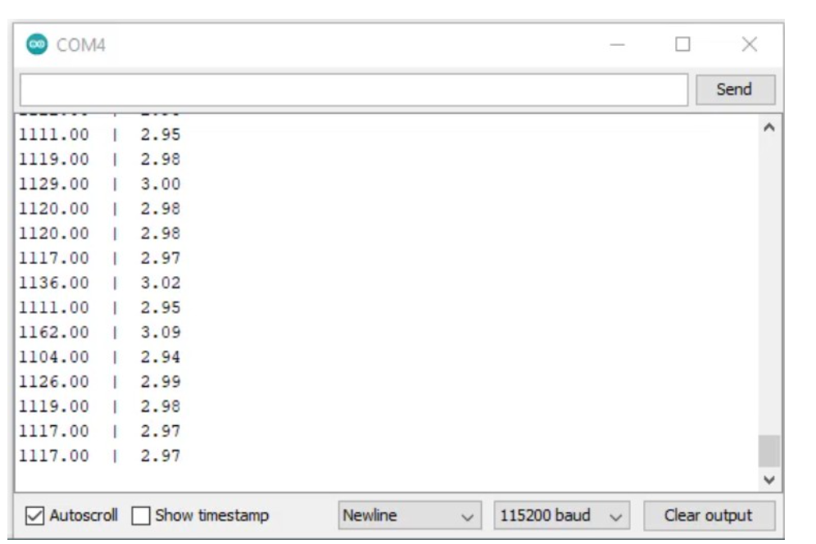

**Working Observation:**

* The Lime PH value is 2.8.
* The Milk Value is between 6.5 to 6.7
* Water PH Value is 7

**RESULT:** The PH value for the various substance is obtained by employing the PH sensor with Arduino microcontroller Board and Tested successfully.